OOP Lab 10
Task 1:
#include<iostream>
#include<string.h>
#include <fstream>
using namespace std;

int main(){
string name;
string message;
cout<<"Enter a message:";
getline(cin,message);
cout<<"Enter name:";
getline(cin,name);
fstream f("task1.txt",ios::out);
if(!f)
cout<<"File not created";
f<<name<<endl<<message;
f.close();
}
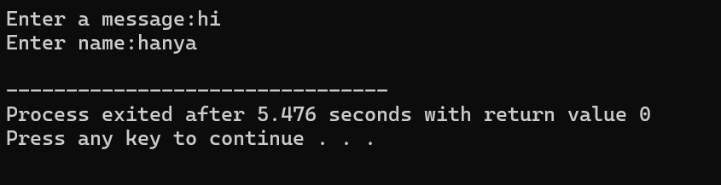
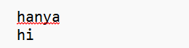
Task 2:
#include<iostream>
#include<string.h>
#include <fstream>
using namespace std;

int main(){
char c;
ofstream f;
f.open("task2.txt",ios::app);
string message;
do{ cout<<"Enter a message for diary:";
getline(cin,message);
f<<message;
cout<<"\nEnter e if you want to exit:";
cin>>c;
cin.ignore();
}while(c!='e');
f.close();}
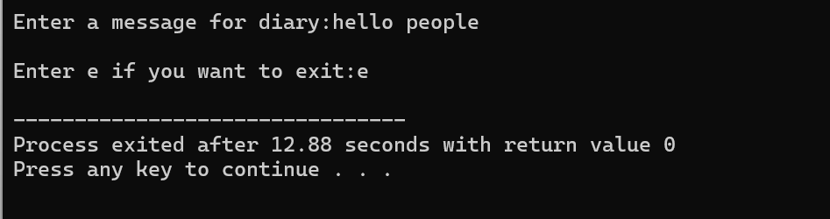
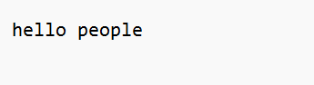
Task 3:
#include<iostream>
#include<string.h>
#include <fstream>
using namespace std;

int main(){
char c;
ofstream f;
f.open("signup.txt",ios::app);
string name,email;
do{
cout<<"Enter name:";
cin>>name;
cout<<"Enter email:";
cin>>email;
f<<name<<"\t"<<email;
cout<<"\nEnter y if you want to enter more records";
cin>>c;
}while(c=='y');
f.close();

}

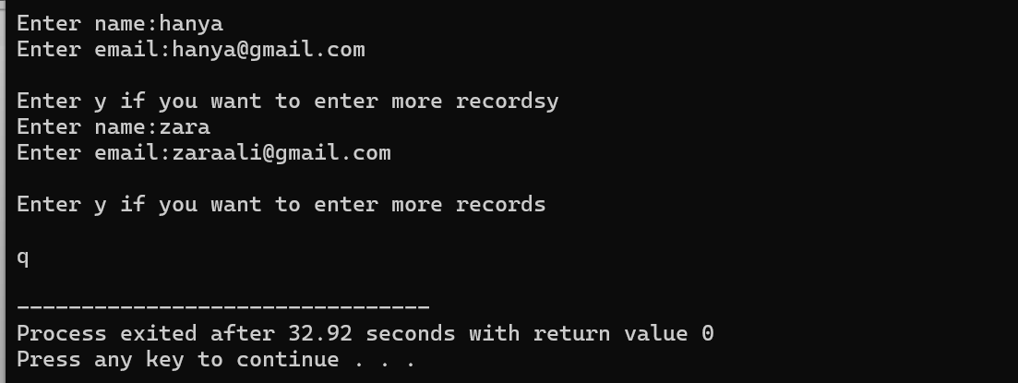

Task 4:
#include <iostream>
#include <fstream>
#include <ctime>
using namespace std;

int main() {
ofstream logFile("log.txt", ios::app);
if (!logFile) {
cerr<<"Error!"<<endl;
return 1;
}
time_t now= time(0);
char* dt = ctime(&now);
logFile<<"System started at:"<<dt;
cout<<"Startup logged successfully."<<endl;
logFile.close();
return 0;
}
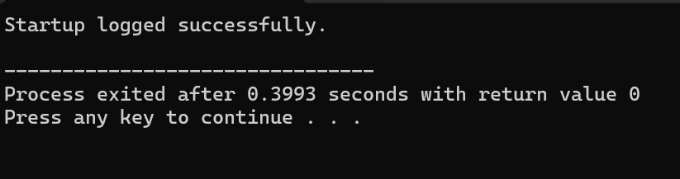

Task 5:
#include <iostream>
#include <fstream>
#include <string>
#include <sstream>
using namespace std;
int main() {
ifstream file("story.txt");
if (!file) {
cout<<"Error";
return 1;
}
string line, word;
while (getline(file, line)) {
istringstream iss(line);
while (iss>>word) {
cout <<word<<"\n";
}
}
file.close();
return 0;
}
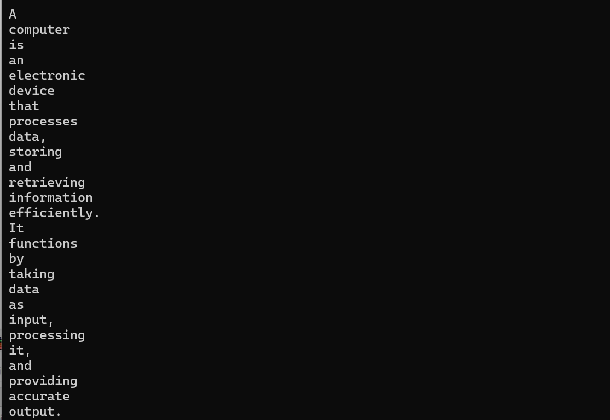

Task 6:
#include <iostream>
#include <fstream>
#include <cctype>
using namespace std;
int main() {
ifstream file("secret.txt");
if (!file) {
cout<<"Error";
return 1;
}
char ch;
int count=0;
while (file.get(ch)) {
if (isupper(ch)) {
count++;
}
}
file.close();
cout<<"Uppercase signals found: "<<count<<"\n";
return 0;
}
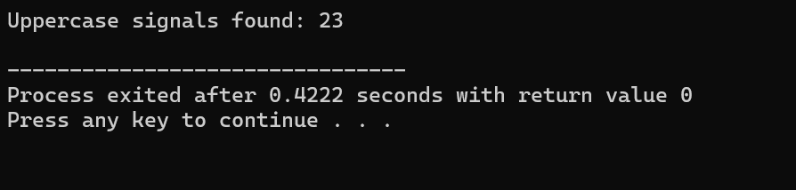
Task 7:
#include <iostream>
#include <fstream>
#include <string>
using namespace std;
struct Student {
char name[50];
int id;
float gpa;
};
int main() {
int numStudents;
cout<<"How many students do you want to enter? ";
cin>>numStudents;
ofstream outFile("students.dat", ios::binary);
if (!outFile) {
cerr<<"Error opening file for writing!"<<endl;
return 1;
}
for (int i = 0; i < numStudents; i++) {
Student s;
cout<<"\nEnter details for student"<<i + 1<<":"<<endl;
cout<<"Name:";
cin.ignore();
cin.getline(s.name, 50);
cout<<"ID: ";
cin>>s.id;
cout<<"GPA: ";
cin>>s.gpa;
outFile.write(reinterpret_cast<char*>(&s), sizeof(Student));
}outFile.close();
cout<<"\nDisplaying Student Records\n";
ifstream inFile("students.dat", ios::binary);
if (!inFile) {
cerr<<"Error opening file for reading!"<<endl;
return 1;
}Student temp;
while (inFile.read(reinterpret_cast<char*>(&temp), sizeof(Student))) {
cout<<"ID:"<<temp.id<<endl;
cout<<" Name:"<<temp.name<<endl;
cout<<"GPA:"<<temp.gpa<<endl;
}
inFile.close();
return 0;
}
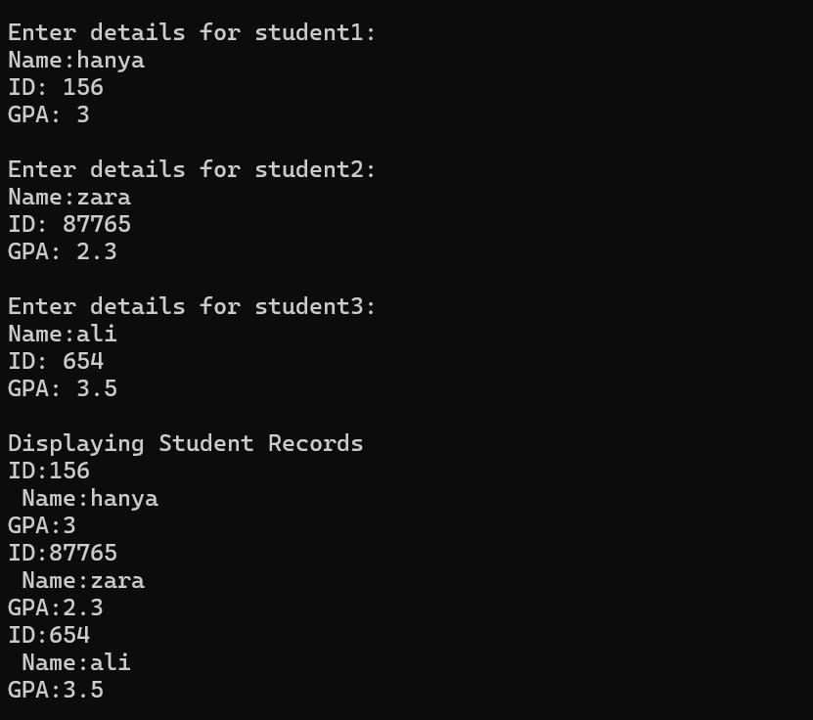

Task 8:
#include <iostream>
#include <fstream>
#include <string>
using namespace std;

int main() {
ifstream file("article.txt");
if (!file) {
cerr<<"The file 'article.txt' exists!"<<endl;
return 1;
}
file.seekg(0, ios::end);
long fileSize=file.tellg();
long midPoint=fileSize / 2;
file.seekg(midPoint, ios::beg);
string line;
getline(file, line);
for (int i = 0; i < 10 && getline(file, line); i++) {
cout << line << endl;
}
file.close();
return 0;
}
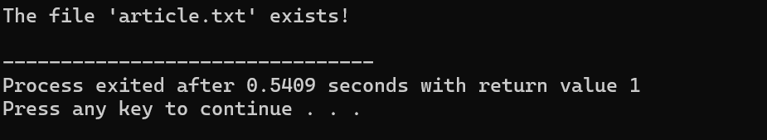

Task 9:
#include <iostream>
#include <fstream>
#include <string>
using namespace std;

int main() {
fstream file("draft.txt", ios::in | ios::out);
if (!file) {
cerr << "Could not open 'draft.txt'!" << endl;
return 1;
}
string word;
long pos = 0;
bool found = false;
while (file >> word) {
if (word == "teh") {
pos = (long)file.tellg() - 3;
found = true;
break;
}
}
if (found) {
file.clear(); /
file.seekp(pos, ios::beg);
file << "the";
cout << "Typo 'teh' corrected to 'the' successfully." << endl;
} else {
cout << "Typo 'teh' not found in document." << endl;
}
file.close();
return 0;
}
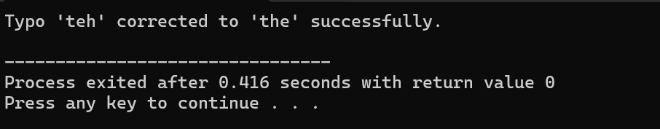

Task 10:
#include <iostream>
#include <fstream>
#include <string>
using namespace std;
int main() {
string logMessage;
ofstream outFile("backup_log.txt", ios::app);
if (!outFile) {
cerr<<"Error opening log file!"<<endl;
return 1;
}
cout<<"Enter log messages (type 'exit' to stop):"<<endl;
while (true) {
cout<< "> ";
getline(cin, logMessage);
if (logMessage == "exit") break;
outFile<<logMessage<<endl;
long currentSize = outFile.tellp();
cout<<"[System] Current file size:"<<currentSize<<"bytes"<<endl;
}
outFile.close();
return 0;
}
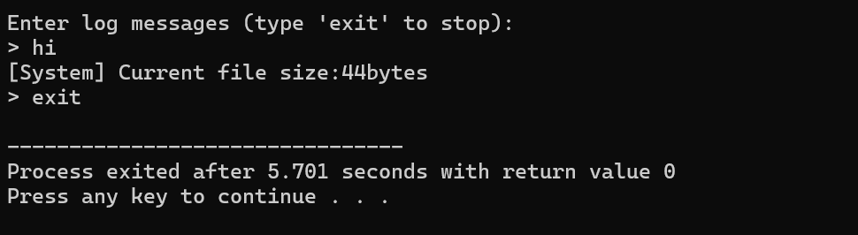

Task 11:
#include <iostream>
#include <fstream>
#include <string>
#include <cctype>
using namespace std;
int main() {
ifstream inFile("article.txt");
if (!inFile) {
cerr<<"Error: article.txt not found."<<endl;
return 1;
}
int chars = 0, words = 0, lines = 0, puncts = 0;
char ch;
bool inWord = false;
while (inFile.get(ch)) {
chars++;
if (ispunct(ch)) puncts++;
if (ch == '\n') lines++;
if (isspace(ch)) {
inWord = false;
} else if (!inWord) {
inWord = true;
words++;
}
}
if (chars > 0 && lines == 0) lines = 1;
inFile.close();
ofstream report("report.txt");
report<<"Total Characters:"<<chars<<endl;
report<<"Total Words:" << words<<endl;
report<<"Total Lines:" << lines<<endl;
report<<"Punctuation Marks: "<<puncts<<endl;
report.close();
cout<<"Results saved to report.txt" <<endl;
return 0;
}
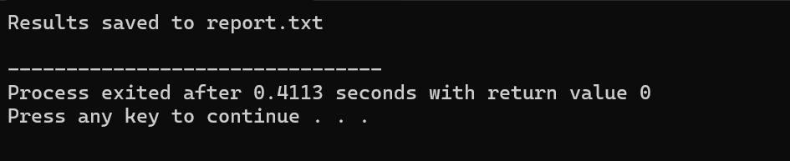

Task 12:
#include <iostream>
#include <fstream>
using namespace std;

int main() {
ifstream file("article.txt");
if (!file) {
cerr<<"Error: File 'article.txt' not found."<<endl;
return 1;
}
long offset;
cout<<"File Debugger" <<endl;
cout<<"Enter byte offset to jump to:";
cin >>offset;
cout<<"Pointer position before seek: "<<file.tellg()<<endl;
file.seekg(offset, ios::beg);
if (file.fail()) {
cout<<"Error: Invalid offset or jump failed." <<endl;
return 1;
}
cout<<"Pointer position after seek: "<<file.tellg()<<endl;
cout<<"\nInspecting next 100 characters:"<<endl;
char buffer[101];
file.read(buffer, 100);
streamsize bytesRead= file.gcount();
buffer[bytesRead] = '\0';
cout<<buffer<<endl;
cout<<"Pointer position after read:"<<file.tellg()<<endl;
file.close();
return 0;
}
